Ujian Akhir Praktikum - Semester Ganjil 2020/2021
Practicum Final Exam –Odd Semester Year 2020/2021
Matakuliah  Subject |  |  | COMP6153 – Operating System |  |  | 
Kelas  Class | : | BE01 / BG01 / BB01 / BC01 / BF01 / BA01 / BD01 |  | Tanggal Mulai  Start Date | : 22 December 2020
Kelas  Class | : |  |  | Waktu Mulai  Start Time | : 15.20
Dosen  Lecturer | : | D1152 - Drs. Fajar Suprapto, M.Sc.  D1279 - Tatang Gunar Setiadji, M.Eng.  D2632 - Dr. Zulfany Erlisa Rasjid, B.Sc., MMSI.  D3089 - Rubil, S.T., M.T.  D3366 - Bayu Kanigoro, S.Kom., M.T.  D3778 - Benfano Soewito, M.Sc., Ph.D  D5970 - Wawiko Supeno, S.Si., MTI. |  | Tanggal Selesai  End Date | : 22 December 2020
Dosen  Lecturer | : |  |  | Waktu Selesai  End Time | : 17.20

PERATURAN UJIAN:
Exam Regulations:
- Mahasiswa tidak diperbolehkan berdiskusi dan/atau bekerja sama dengan peserta ujian lainnya
Student is not allowed to discuss and/or work together with other exam participants
- Mahasiswa tidak diperbolehkan untuk membuka dan menyalin dari BUKU atau CATATAN, VIDEO dari pengajar (recording kelas, VBL, Youtube, dsb) dan REFERENSI lainnya
Student isn't allowed to open and copy from any resources such as notes, videos (class recording, VBL, Youtube, etc) and other references
- Mahasiswa tidak diperbolehkan membuka dan menyalin jawaban dari internet (google, stackoverflow, dsb)
Student isn't allowed to open and copy answer from the internet (google, stackoverflow, etc)
- Asisten BERHAK memberi nilai 0 (NOL) bagi peserta ujian yang melakukan segala bentuk kecurangan
Assistant is able to give 0 (ZERO) score for exam participant who does any cheating actions
- Kumpulkan jawaban tepat pada waktunya, apabila terlambat mengumpulkan maka jawaban tidak akan dikoreksi dan nilai mahasiswa adalah 0
Submit the answer on time, if not, then the answer will not be checked, and the students will receive 0 (ZERO)
- Bila Anda tidak membaca peraturan ini, maka Anda dianggap telah membaca dan menyetujuinya
If you have missed to read these regulations, so you are considered to have read and agreed on it

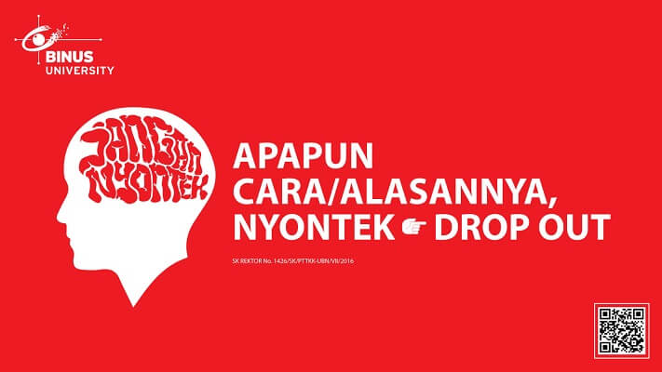

SOFTWARE YANG DIGUNAKAN:
Software will be used:
- Java 8
- Eclipse 2020.6
- NachOS 5.0j

FILE YANG DIKUMPULKAN:
File must be collected:
- JAVA
- CLASS

PERHATIAN!
Attention!
- Bagi yang mengerjakan tidak sesuai dengan soal, maka akan diberikan nilai NOL (0)
For those who do not work in accordance with the exam case will be marked as ZERO (0)
- Bagi yang mengerjakan tidak sesuai dengan software dan versi yang telah ditetapkan, maka akan tetap dikoreksi dengan software dan versi yang telah ditetapkan
For those who do not work in accordance with the software and specific version will be corrected by the predefined software and version
- Kompres semua jawaban yang akan diunggah. Pastikan format pengumpulan nama file dan ekstensi sesuai dengan format berikut: [NIM]-[NAMA].zip
Compress all file that will be uploaded. Make sure the format for collecting file name and extension according to the following format: [NIM]-[NAME].zip

Soal
Case

Important Notes:
- Use your own Console and Scheduler (FIFO)
- You must use Semaphore to control operation
- You must use Timer to generate tick of time
- Use KThread

ZOSCE
Old man Creed Bratton has ask the intern to create a social media account for him. Fearing that exposing the filthy mind of the psychopathic old man, Howard has decided to create his own social media to prevent the world from seeing an abomination. The social media is called ZOSCE. It’s a social media which features a functionality to create a post/tweet that could be viewed by all people. As it is a simple social media, the user doesn’t need an account to create a post. They just need to create a tweet and post it under a name that could be anything or just anonymous. As a programmer, you are asked to create the application using nachOS in Java programming language.
In the start of the application, the program will show 4 menus which represent features in the application which are:
- Check Timeline
- Create Tweet
- Delete Tweet
- Logout
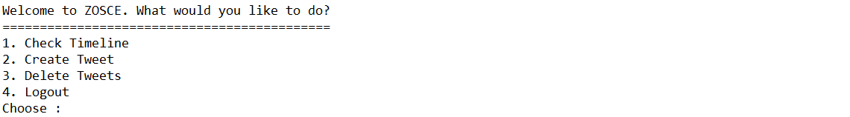
Figure 1. Main menu

- Check Timeline
The first menu option lets the user check all available tweets. This option requires the data that is stored in the “tweets.txt” file. You must create a file system that could read the file. After reading the file, the following will occur:
- Check if there are tweets available. If there are no tweets, the application will show an error message to the user.
Figure 2. Timeline Error Message
- Otherwise, if there are tweets already, the application will show all tweets received using KThread and Scheduler (FIFO concept). The tweets will be shown with delay 2000 milliseconds (using Thread sleep).
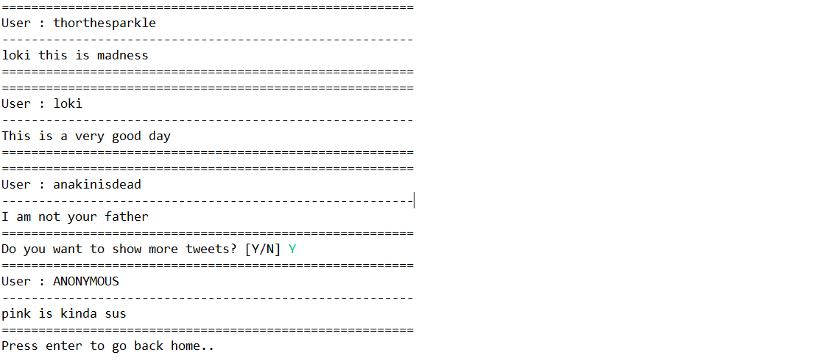
Figure 3. View Timeline
- Notice that upon showing three tweets, the program will prompt whether you want to show more tweets or not.
- If the user inputs ‘Y’, show 3 tweets if available.
- If the user inputs ‘N’, the user can press enter to go back home.
- If there are less than 3 tweets, the prompt will not show.

- Create Tweet
The second option of the menu (Create Tweet) allows the user to create a new tweet under a username of their choosing. The process follows the following steps which are:
- Ask the user to input the tweets content. The content must be between 1 – 50 characters.
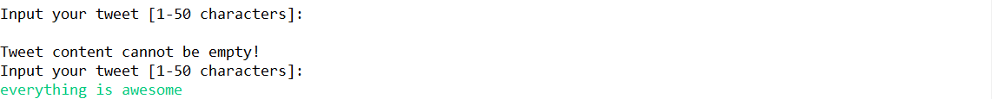
Figure 4. Tweet Content input

- Ask the user to input tweet creators username. The username has the max of 20 characters but could be left empty in case the creator wants to remain anonymous.
Figure 5. Tweet Creator input
- If the user left the username anonymous, then an extra message saying “Anonymous tweets cannot be deleted” will be shown.
- After all the required input has been filled, save the input to a file named “tweets.txt” with the following format and show success message to the user.
- NOTE : To make sure that the data doesn’t mess up, create the tweet using the separator character (‘#’).
[Tweet Content]#[Tweet Creator]

- Delete Tweet
The third option in the menu allows the user to delete a tweet according to the username. The deleting process follows the following steps which are:
- The application will prompt the user to input a username. The username inputted will be used to retrieve all tweets created under the username. Leaving the input empty will show an error saying that anonymous tweets cannot be deleted.
Figure 6. Twitter Creator Validation
- If the username inputted hasn’t made any tweet, then the program will show an error message as such.
Figure 7. No Tweet Error Message
- Otherwise, the application will print all tweets made by the username and ask the user what index of the tweet that needs to be deleted.
- The deleted index starts from 1 to tweet list data size. The user can also input 0 to exit from the menu.
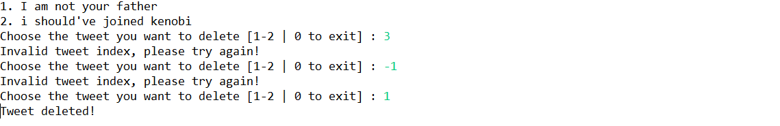
Figure 8. Delete tweet
- After tweet deletion has been completed successfully, update the data in file “tweets.txt” and direct the user back to the main menu.

- Logout
If the user chooses the fourth Menu (Logout), the application will print the time in minutes using a timer and show the user a message that says: “Goodbye!”.
Figure 9. Exit

